**<Insert Bank Name> Presents**

**<Insert Bank Name>** | Chat With The Experts™ Series

**SPACE IS LIMITED**

To register please call <Bank Phone Number> and ask for

<Insert Name> to reserve your spot before it’s gone.

**Date: <Date of Event>**

**Time: <Event Time>**

**ONE-TIME ONLY SPECIAL EVENT**

**Beyond Resilience**

**Trench-Tested Tools to Thrive Under Pressure**

You don’t need an earthquake to have a disaster. Many industries are in a state of tremendous turmoil and some will not survive the change. And yet, this is a time of extraordinary opportunity for individuals and organizations that can adapt, engage and innovate. Mere resilience is no longer enough.

Are you ready to thrive?

**In this session, you will discover:**

* **How to keep your eye on the direction that you want to go.** That subtle shift will have tremendous ramifications on shifting focus away from the problem.
* **How to get people into a powerful state.** Asking the right questions gives tremendous insights needed to eliminate a victim mentality.
* **The right questions to ask during situations of high stress or crisis.** Take your team from disengaged to invested, not just engaged, even when you don’t have all the resources you need.
* **How to go one notch further.** Once the team is invested, the next step is ownership and how to lead up the chain of command.
* **How to better develop your executive team.** It’s not about matching culture anymore. It’s about diversity, true diversity of all kinds.

**Guest: Dr. Dan Diamond**

Our Guest has a passion for equipping people to perform under pressure. He founded and serves as the Director of the Nation’s first state-affiliated medical disaster response team.

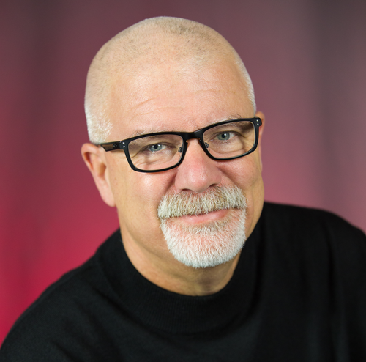

**Host: Roxanne Emmerich**



Your host, *New York Times* bestselling author, award winning speaker, 3-time Entrepreneur of the year and CEO of

The Emmerich Group.